Website testing checklist
Add or delete rows in each table as required.
Website URL: https://jwoolley1.tafewest.com/Webpage/www/index.html
Client requirements: Click or tap here to enter text.

Testing activity: Compatibility and functionality
Page name | Browser name and version | Elements being tested  (text/ images/ links/ tables/ forms) | Screenshot | Pass/fail | How to correct errors
Index.html | Google Chrome | Consistency tests  All text, imagery, links, tables and forms |  | Pass  Zoomed out for full screen view  All functions operate as expected  All imagery and text remain in the correct format | N/A
Index.html | Microsoft edge | Consistency tests  All text, imagery, links, tables and forms |  | Pass  All functions operate as expected  All imagery and text remain in the correct format | N/A
Index.html | Mozilla Firefox | Consistency tests  All text, imagery, links, tables and forms |  | Pass  All functions operate as expected  All imagery and text remain in the correct format | N/A
About.html | Google chrome | Consistency tests  All text, imagery, links, tables and forms |  | Pass  All functions operate as expected  All imagery and text remain in the correct format | N/A
About.html | Microsoft edge | Consistency tests  All text, imagery, links, tables and forms | 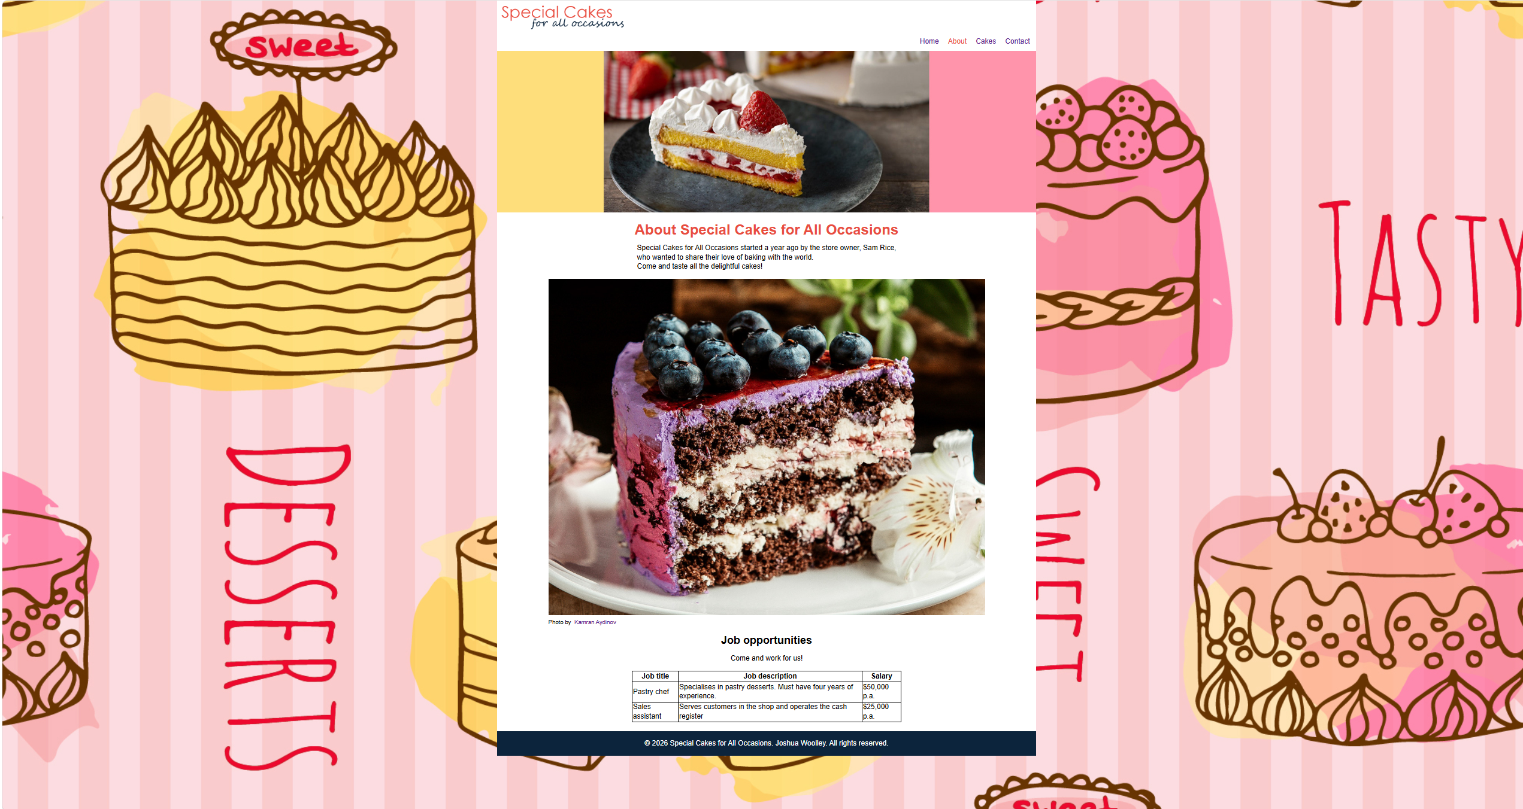 | Pass  All functions operate as expected  All imagery and text remain in the correct format | N/A
About.html | Mozilla Firefox | Consistency tests  All text, imagery, links, tables and forms | 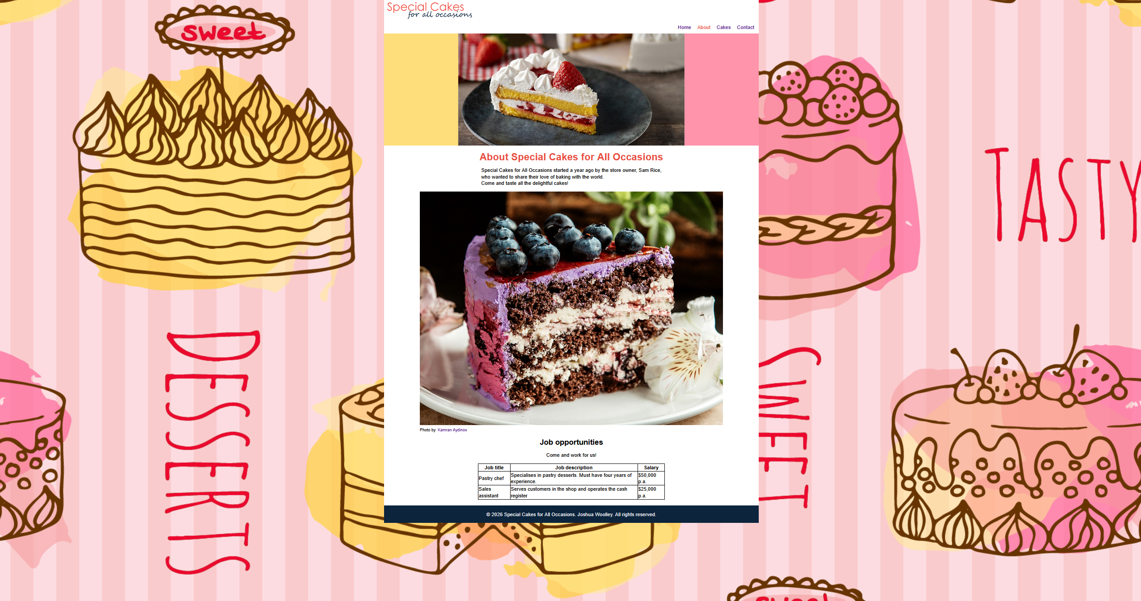 | Pass  All functions operate as expected  All imagery and text remain in the correct format | N/A
Cakes.html | Google Chrome | Consistency tests  All text, imagery, links, tables and forms | 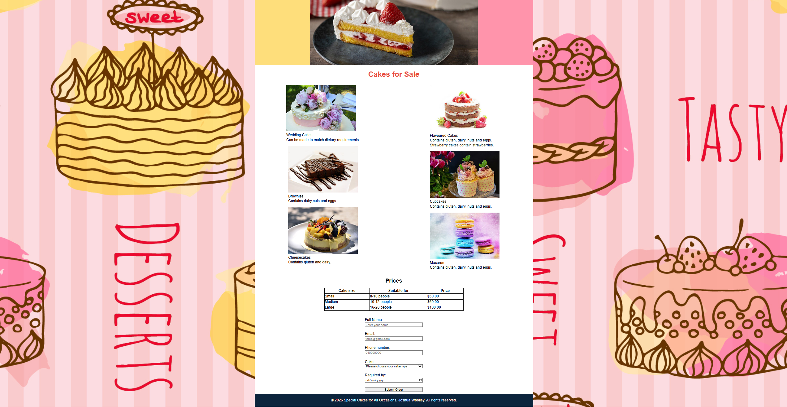 | Pass  All functions operate as expected  All imagery and text remain in the correct format | N/A
Cakes.html | Microsoft  Edge | Consistency tests  All text, imagery, links, tables and forms | 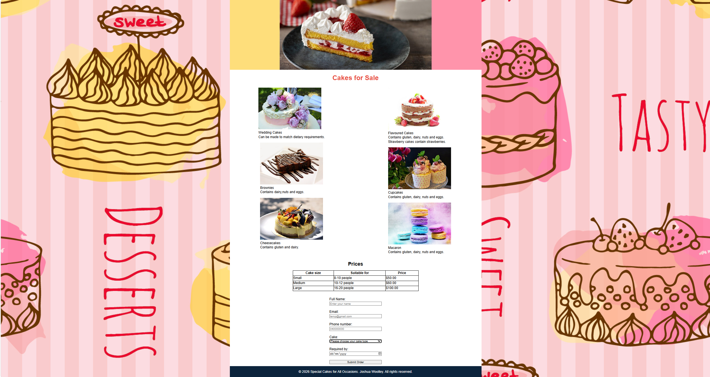 | Pass  All functions operate as expected  All imagery and text remain in the correct format | N/A
Cakes.html | Mozilla Firefox | Consistency tests  All text, imagery, links, tables and forms | 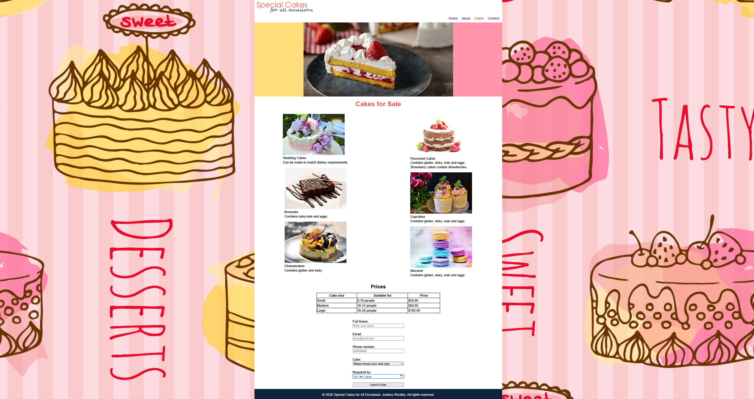 | Pass  All functions operate as expected  All imagery and text remain in the correct format | N/A
Contact.html | Google Chrome | Consistency tests  All text, imagery, links, tables and forms | 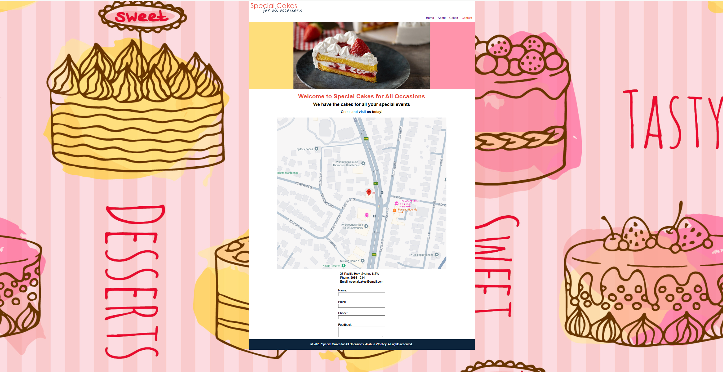 | Pass  All functions operate as expected  All imagery and text remain in the correct format | N/A
Contact.html | Microsoft Edge | Consistency tests  All text, imagery, links, tables and forms | 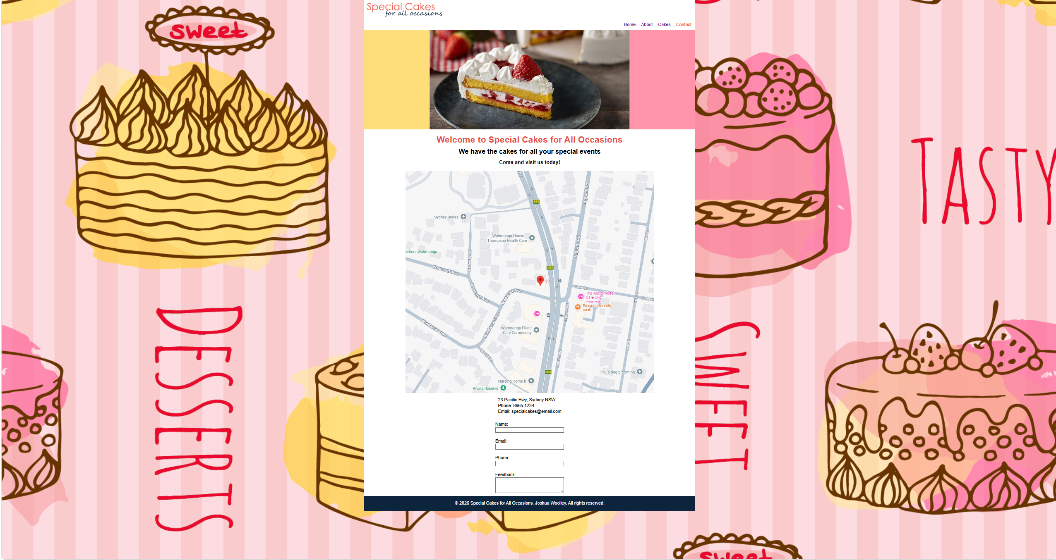 | Pass  All functions operate as expected  All imagery and text remain in the correct format | N/A
Contact.html | Mozilla Firefox | Consistency tests  All text, imagery, links, tables and forms | 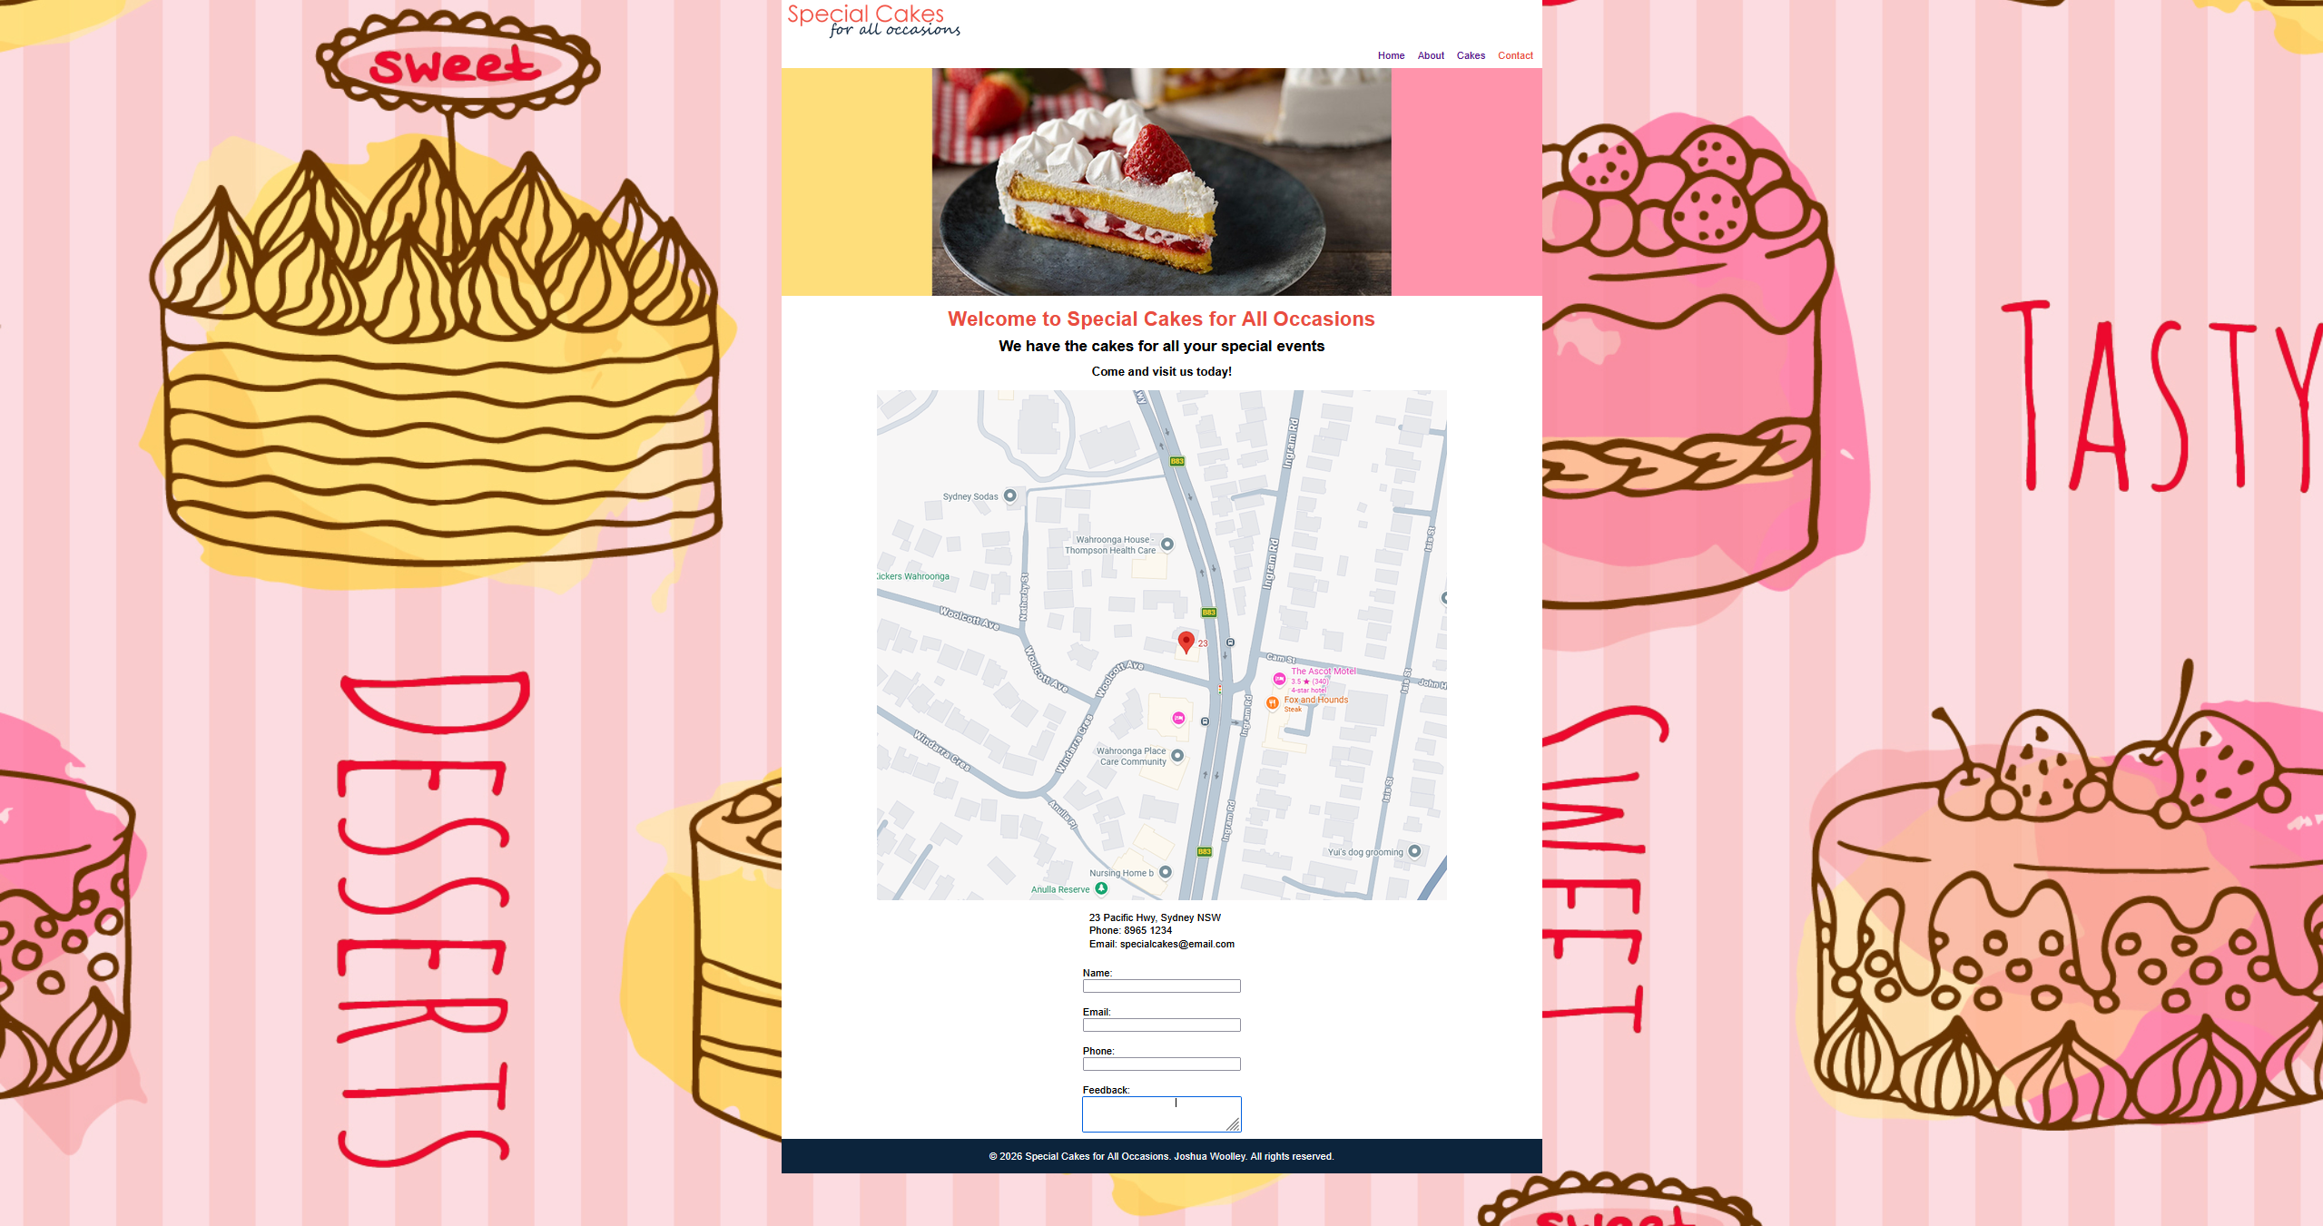 | Pass  All functions operate as expected  All imagery and text remain in the correct format | N/A

Testing activity: Validation
Page name | Screenshot | Pass/fail | How to correct errors
Index.html | 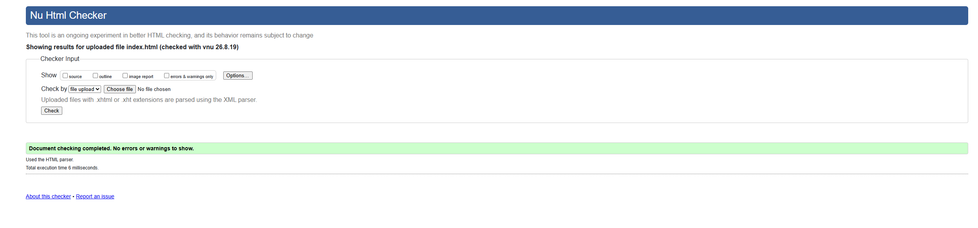 | Pass | Singular error was corrected.  Coded the web banner with width=”1200px”  Deleted the Px from all pages
About.html | 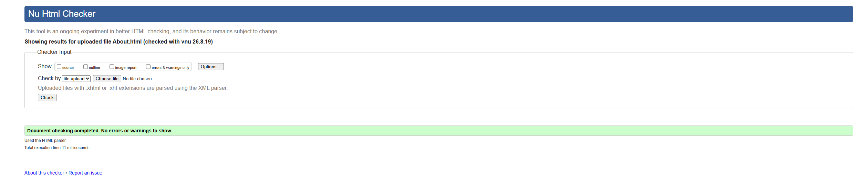 | Pass | No issues outside of the Px issue which has been resolved.
Cakes.html | 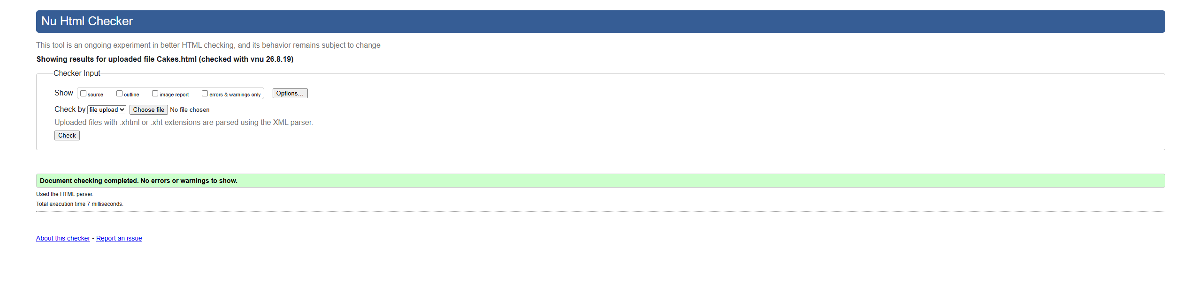 | Fail  Resolved issues  Pass | Had an invalid element in <figcaption.cakes> resolved by removing the .cakes on all code  Certain images did not include an alt attribute to provide text alternative for images.  An unclosed <div> was also providing an error after sorting through the code this issue was resolved.  Contained whitespace in some of my form IDs resolved by removing whitespace.  Was not case sensitive with form labels and IDs resolved by checking my work and adjusting grammar
Contact.html | 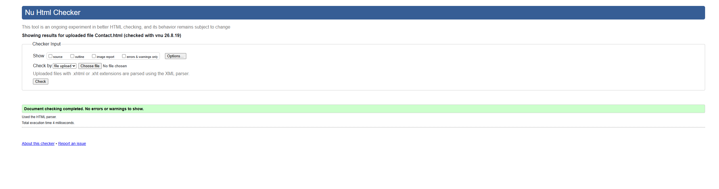 | Fail  Resolved  Pass | Accidentally listed <input for=”tel”>  Instead of <input type=”tel”  Resolved easily

Testing activity: Accessibility
Page name | Screenshot | Pass/fail | How to correct errors
Index.html | 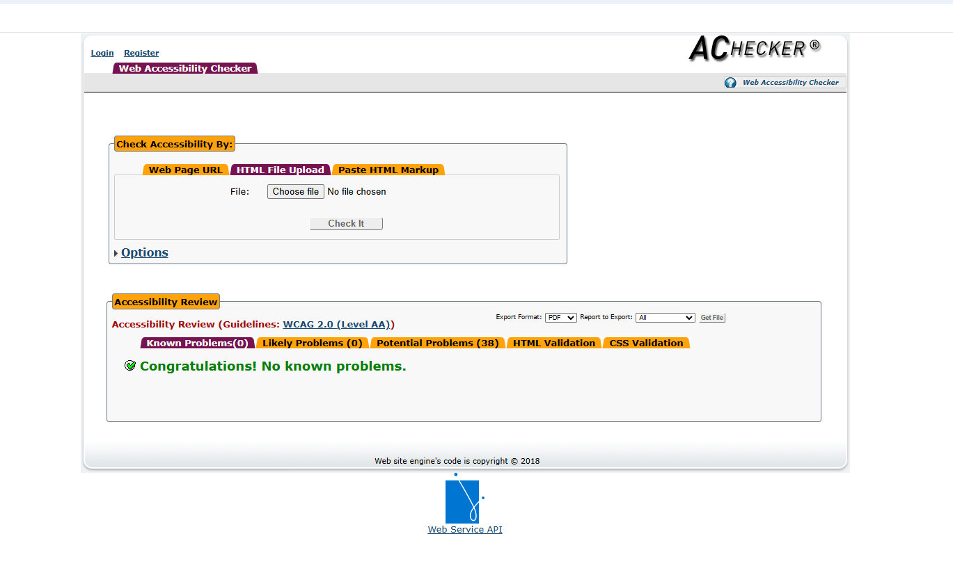 | Pass | After a rigorous amount of effort I resolved the sole issue of anchor does not have text in the logo image <a>
About.html | 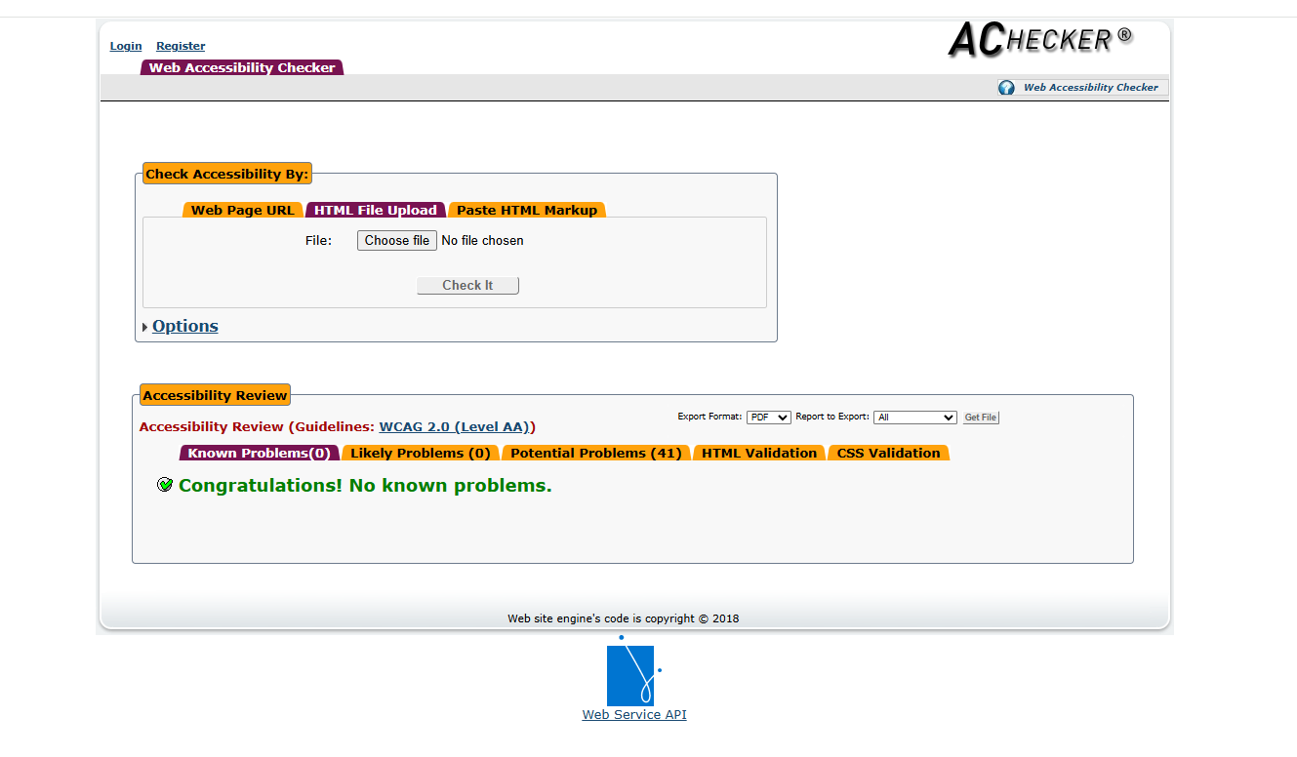 | Pass | N/A
Cakes.html | 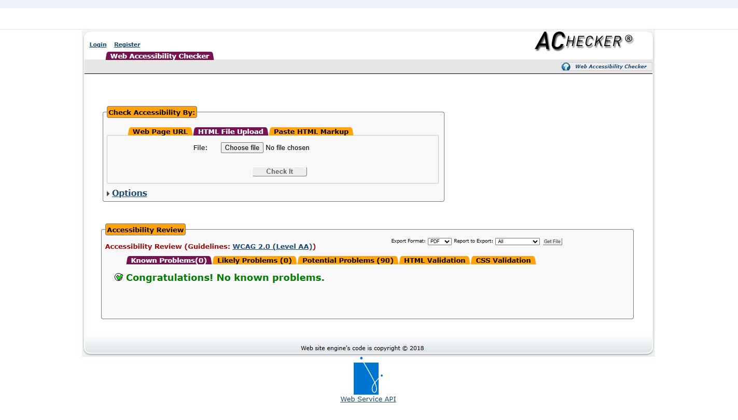 | Pass | N/A
Contact.html | 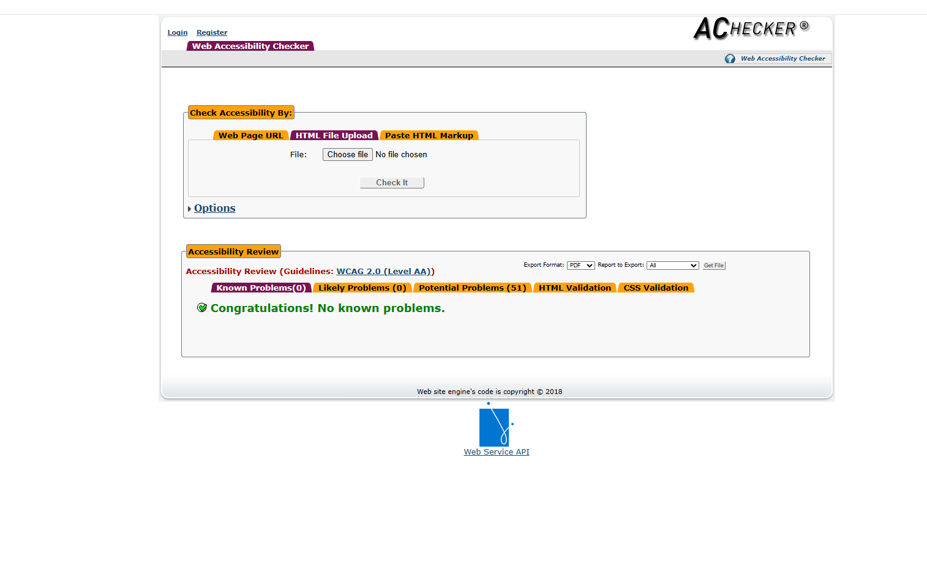 | Pass | N/A

Testing activity: Security
Testing tool | Screenshot | Pass/fail | How to correct errors
Sucuri | 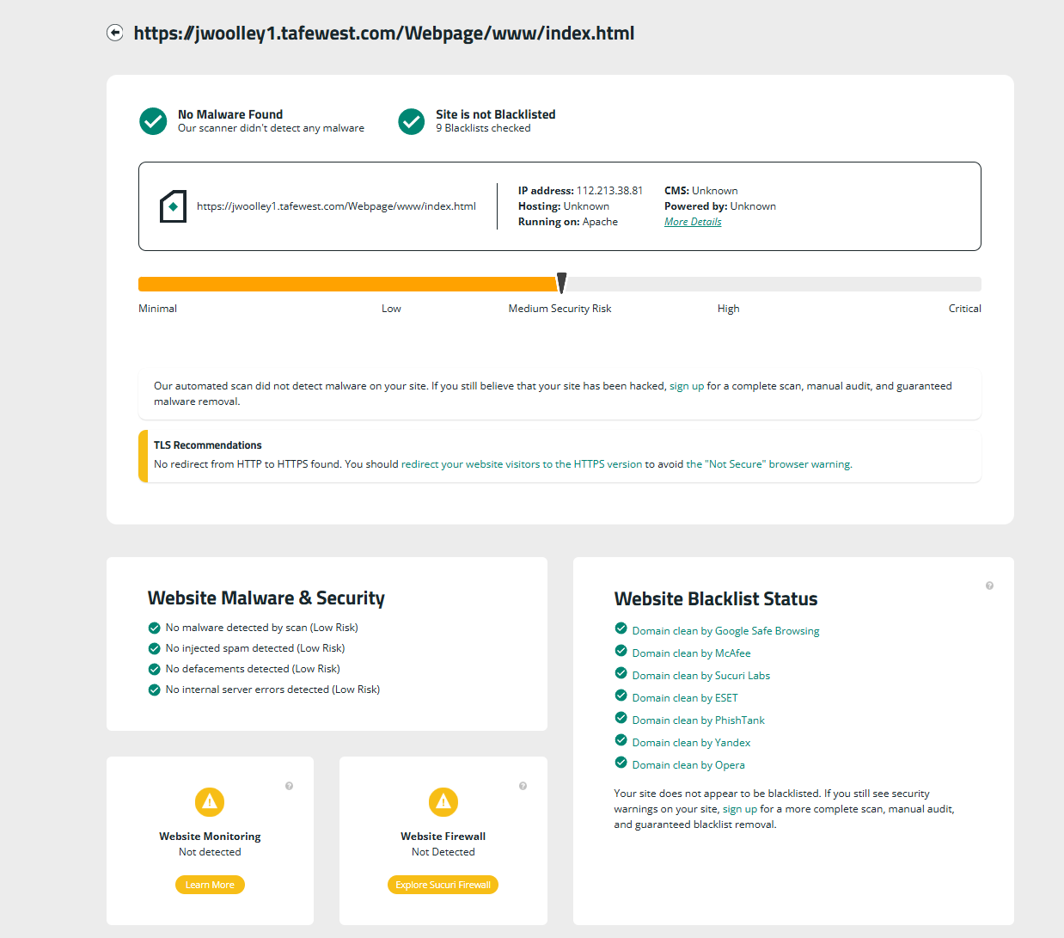 | Pass | The website firewall and monitoring is out of my control.

